**WEEKLY PROGRESS REPORT**

**Sightline Capstone Project**

**Week 16**

**27 April 2019**

**Tai:**

**This week:**

* Working with the Qgroundcontrol with new ground control station (my own laptop).
* Be able to stream video from SLA-1500 hardware to SLA-panel-plus software, and then able to stream video from Sightline software to Qgroundcontrol.

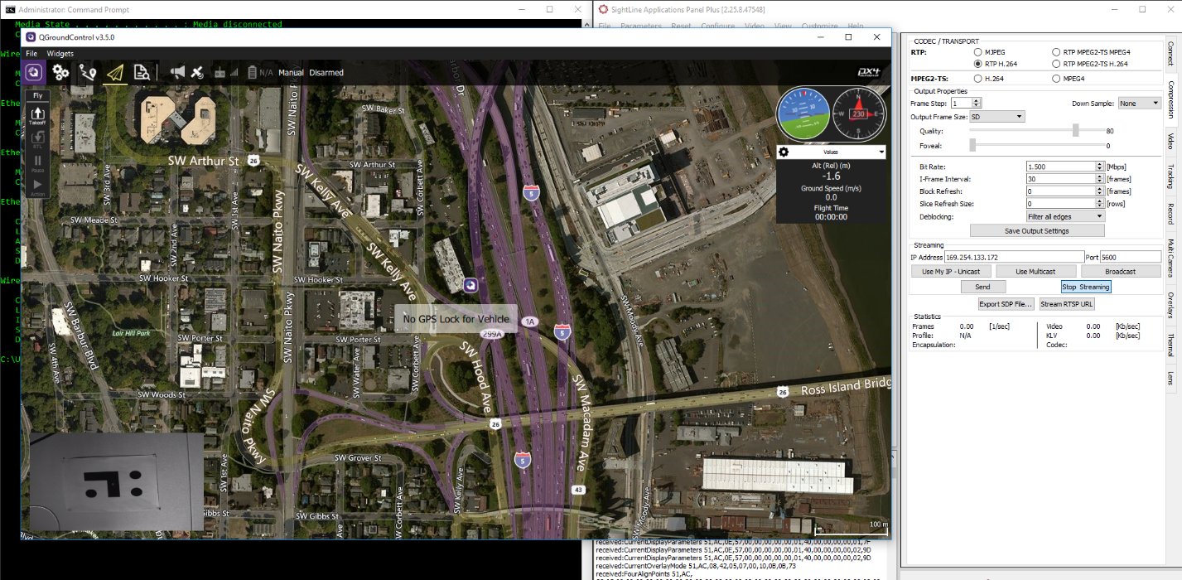

* Try a few different MAVlink control/console, but none of them working. It turns out that Qgroundcontrol **have integrated functional MAVlink console**. I’m able to use that to check all parameter and status of the Pixhawk4.
* To check all parameters which is used/not used, we can use “**param show**” command in MAVlink console.
* The **“listener**” command will show vehicle status by using the command “**listener vehicle_status.**”
* I’m able to check the telemetry connection and communication by using command “**listener telemetry_status**.”

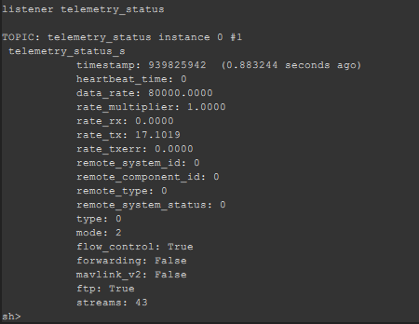

This picture has shown that we have a transmitted signal from SLA-1500-hardware (rate_tx) to Pixhawk 4 at mode 2 (Telem2, or I assumed so) because I only have SLA-1500-hardware connect to serial port Telem2 (I have no GPS or telemetry connected to Pixhawk 4). This confirmed that the Qgroundcontrol/Pixhawk 4 actually see the signal came from SLA-1500-hardware.

Additionally, the **listener** command can be used to inspect the values of sensors and other topics (using **listener obj/** to check all topics/parameter), and it can be used even when QGC is connected over a wireless link (telemetry link when vehicle is flying).

**Next week:**

* Connect Pixhawk 4 wirelessly using telemetry to check the vehicle status and signal.
* Possible to do the flight test, or prepare for the new flight test since we have some new propeller.

**Question:**

**Kimball:**

**This Week:**

* Issues were found with the board layout design by the Sightline team. There are problems with translation from Eagle to Altium, which doesn’t affect the design but does create some confusion.
* Although design rules were downloaded from Sunstone manufacturer and the board passed DRC with no errors in Eagle, Sightline found some issues with the board design using Altium DRC and from visual inspection of the Eagle design.
* One of the issues has been isolated to clearance < 6 mil between same signal traces/vias not creating an error when the DRC is ran in Eagle.
* All parts have been approved and are available/in stock on the current BOM

**Next Week:**

* Meeting first thing Monday at Sigthline to fix issues with board design and finalize gerber files for manufacturing
* Work on the following final documentation:
  + Test Plan for SLA1500 CAM
  + Design Report
  + Power Point Presentation
  + Poster Design

**Comments/Questions:**

None at this time